Create Query:

CREATE TABLE IF NOT EXISTS PASSENGER (

PASSENGER_NAME VARCHAR(20) NULL DEFAULT NULL,

CATEGORY VARCHAR(10) NULL DEFAULT NULL,

PASS_GENDER CHAR,

BOARDING_CITY VARCHAR(50) NOT NULL,

DESTINATION_CITY VARCHAR(50) NOT NULL,

PRICE_ID INT NOT NULL,

FOREIGN KEY (PRICE_ID) REFERENCES PRICE (PRICE_ID));

CREATE TABLE IF NOT EXISTS PRICE (

PRICE_ID INT NOT NULL,

BUS_TYPE VARCHAR(15) NOT NULL,

DISTANCE INT NOT NULL,

PRICE INT NOT NULL,

PRIMARY KEY (PRICE_ID)

);

Insert Statements

insert into PRICE values(10001,"Sleeper",350,770);

insert into PRICE values(10002,"Sleeper",500,1100);

insert into PRICE values(10003,"Sleeper",600,1320);

insert into PRICE values(10004,"Sleeper",700,1540);

insert into PRICE values(10005,"Sleeper",1000,2200);

insert into PRICE values(10006,"Sleeper",1200,2640);

insert into PRICE values(10007,"Sleeper",350,434);

insert into PRICE values(10008,"Sleeper",1500,3300);

insert into PRICE values(20001,"Sitting",500,620);

insert into PRICE values(20002,"Sitting",500,700);

insert into PRICE values(20003,"Sitting",600,744);

insert into PRICE values(20004,"Sitting",700,868);

insert into PRICE values(20005,"Sitting",1000,1240);

insert into PRICE values(20006,"Sitting",1200,1488);

insert into PRICE values(20007,"Sitting",1500,1860);

insert into PASSENGER values("Sejal","AC","F","Bengalur","Chennai",10001);

insert into PASSENGER values("Anmol","Non-AC","M","Mumbai","Hyderabad",20004);

insert into PASSENGER values("Pallavi","AC","F","Panaji","Bengaluru",10003);

insert into PASSENGER values("Khusboo","AC","F","Chennai","Mumbai",10008);

insert into PASSENGER values("Udit","Non-AC","M","Trivandrum","Panaji",10005);

insert into PASSENGER values("Ankur","AC","M","Nagpur","Hyderabad",20001);

insert into PASSENGER values("Hemant","Non-AC","M","Panaji","Mumbai",10004);

insert into PASSENGER values("Manish","Non-AC","M","Hyderabad","Bengaluru",20002);

insert into PASSENGER values("Piyush","AC","M","Pune","Nagpur",20004);

Table Data:

Price Table

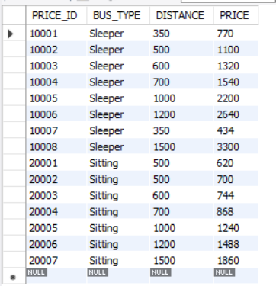

Passenger Table

